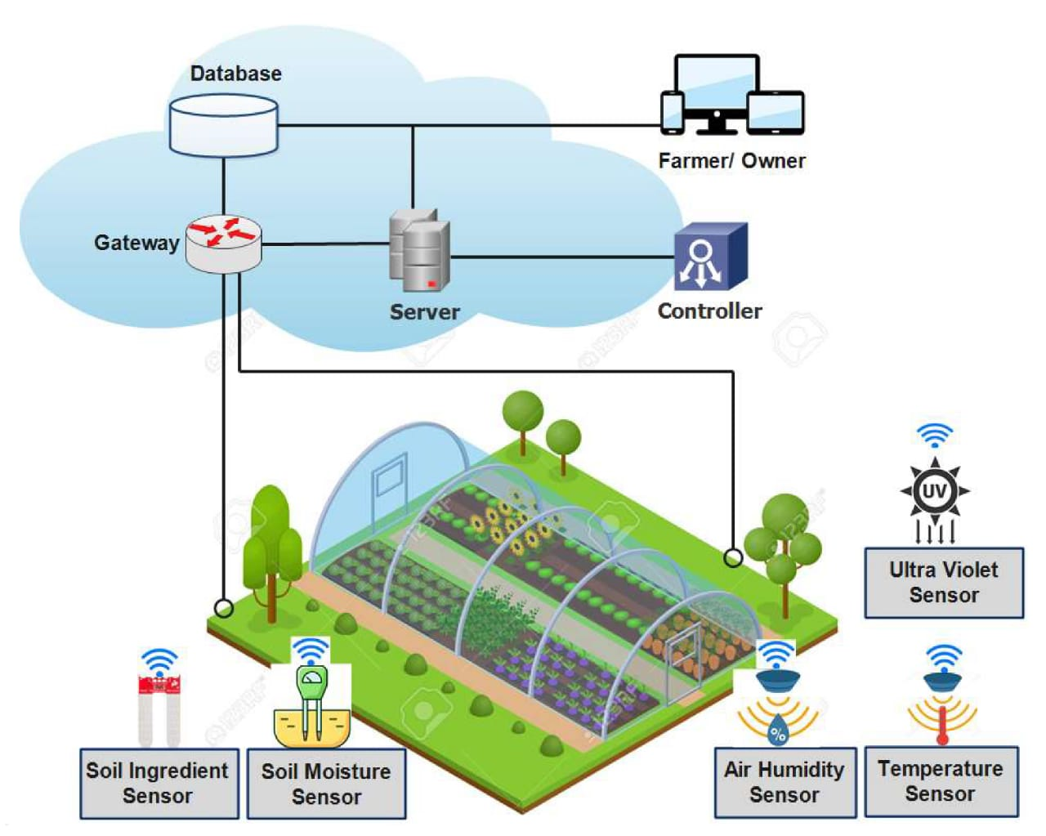 Project Design Phase 1

|  |  |
| --- | --- |
| Date | 03 october 2022 |
| Team ID | PNT2022TMID33042 |
| Project Name | Smart Farmer |
| Maximum Marks | 4 Marks |

Solution Architecture